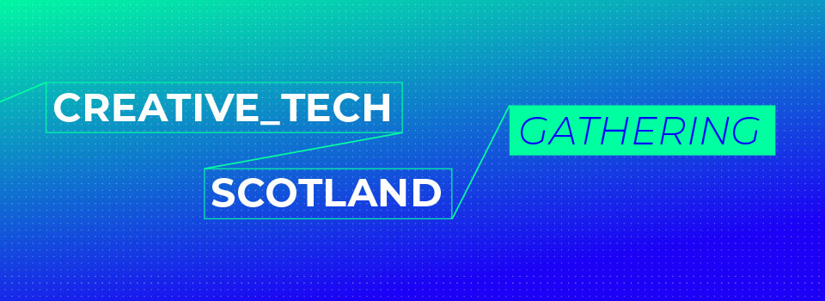

MusicTech Fest Labs 2022 – Attendance Support Funding, October 9-16, Aveiro, Portugal

CreativeTech Scotland Gathering have established a partnership with MTF Labs (www.mtflabs.net) and Creative Scotland with Scottish Music Industry Association to support development for Scotland-based creative practitioners experimenting and innovating with music technology, either in collaboration with other music/sound practitioners or those with science and technology expertise.

About the Partners

MTF Labs bring together musicians, technologists, performers and scientists to collaborate on societal challenges. The theme for MTF Lab 2022 in Aveiro will be the challenge of climate change and rising sea levels on the Built Environment. MTF Lab activity and themes in previous years can be viewed at https://mtflabs.net and the experience of MTF Labs can be viewed here;
Part 1: https://vimeo.com/687076497 Part 2: https://vimeo.com/687077264 .

The CreativeTech Scotland Gathering (CTSG) was held on 25 March 2022 (www.ctsg.scot), enabled by the Scottish Government’s Scottish Technology Eco-System Review Fund. Although initially a one-off fund and event, the response was so encouraging that the CreativeTech Scotland Gathering will return in Spring 2023 led by Edinburgh Futures Institute. CTSG will also deliver two dedicated sectoral events between the annual Gatherings. These dedicated sector events will be designed in collaboration with the corresponding sector trade associations, creative companies and practitioners.

Creative Scotland is the public body that supports the arts, screen and creative industries across all parts of Scotland on behalf of everyone who lives, works or visits here. It enables people and organisations to work in and experience the arts, screen and creative industries in Scotland by helping others to develop great ideas and bring them to life. Creative Scotland distributes funding from the Scottish Government and The National Lottery. (www.creativescotland.com)
The Scottish Music Industry Association (SMIA) is a not-for-profit trade body and membership organisation which exists to strengthen, empower and unite Scotland’s music industry. As a Creative Scotland Regularly Funded Organisation (RFO), the SMIA works to create and nurture an inclusive membership community which reflects the full spectrum of Scotland’s music industry. It gives voice to its membership when speaking to Government, Parliament and development organisations and both produces and supports projects and programmes that stimulate sustainability, domestic and international growth, development and innovation in Scotland’s music sector. SMIA services, projects and events are designed to strengthen and increase the value of Scotland’s music industry on the world stage: economically, socially and culturally. (www.smia.org.uk)

Partnership Purpose

Each of the partners recognise the highly skilled and exciting musictech innovators in Scotland and wish to provide opportunity for further collaboration and experimentation, leading to deepened skills, knowledge development, and innovative solutions to challenges, and/or new applications, new experiences or new prototypes. Participation will develop closer connections for Scottish practitioners with their international counterparts, and we anticipate this will support the future formation of international creative collaborations, innovation and co-trading.

Participation

MTF Labs is a fully inclusive and accessible event involving close collaboration between musicians, technologists and scientists, dynamic creative thinking and design of new work/prototypes in situ, and an intensive and fulfilling development experience. Activity is focussed on a theme at each MTF Labs and this year it will be climate change and impact on the built environment.

As this is a collaborative creative process MTF Labs have provided information on their intellectual property policy – ‘Anything a participant creates during the labs or that a participant brings into the event remains their IP. MTF does not ask for, or require assignation of, IP to another party. Projects at MTF Labs are collaborative and experts bring their own works and prior art into those collaboration, that is considered ’Source IP’. New projects that are built on top of that leverage ‘Innovation IP’ created in situ which may be transformative in including and extending the original work but does not affect ownership of the Source IP.’

As a condition of funding successful participants must provide a short report four weeks after returning from the event describing the activity undertaken, their reflections on the development benefits achieved and a note of any potential further activity generated through the experience (e.g. significant contacts, collaborative partnerships initiated, potential commissions or performances and/or new innovation development).

Partnership Support

MTF Labs have allocated free places for a Scottish delegation of 5 practitioners at the next MTF Lab in Aveiro, Portgual from 10th to 15th October 2022. (Participation is Monday to Saturday night, therefore arrival on Sunday 9th, and departure on Sunday 16th Oct.)

Creative Scotland in support of the development aims have awarded financial assistance to the delegation towards the travel and accommodation costs of £1000 per delegate.

CreativeTech Scotland Gathering will build on this development at CTSG 2023, and with the partners including Scottish Music Industry Association will plan for Scotland to host an MTF Labs event in 2024. We would find it invaluable if the successful delegation participants would contribute their first-hand experience in supporting the programme design and in welcoming MTF Labs and the international participants at the event.

Indicative Budget Costs

The travel and accommodation financial support is intended to contribute to the entire cost to enable practitioners to attend. The funding support will not cover the entire investment required.
We have provided estimated costs below to provide a guide for applicants to consider before application.

Hotel: 7 nights @ €100-120 = €700-840 approximately
(Melia Ria Hotel, although others are available)
Flight: Return to Lisbon (9/10 Out:16/10 Return) approximately £200 + Baggage fees
MTF: €200 (5 days @ €40 fee per day to cover all catering - coffees, snacks, lunches, and dinners).
Breakfast is usually provided at the hotels.
Travel: Return transfers between home and local airport approximately £40 and
Lisbon airport to and from Aveiro approximately €40
Hotel to Venue for MTF Labs - Teatro Aveirense approximately €5 per day
Note: Other potential costs to note may include currency exchange fees or online card transaction fees or phone data/call charges depending on your provider, subsistence on travel days.

Total estimated budget range £1205 - £1345.

Application Process

To apply please submit the following application form to inbox@ctsg.scot by 12 noon on 9th September.

Please attach a short bio/CV with the application and please complete and attach the Equalities, Diversity and Inclusion form for monitoring purposes.

The submitted applications will be reviewed and delegates selected by a panel of representatives from MTF Labs, Creative Scotland, CreativeTech Scotland Gathering, and Scottish Music Industry Association.

Successful applicants will be notified by 19th September and supporting finance will be subsequently distributed to be received in advance of the MTF Labs event.

APPLICATION FORM

Attendance Support - MusicTechFest Labs, 9-16 October in Aveiro, Portugal

CONTACT DETAILS (of main applicant)

Name:
Address:
City/Town:
Postcode:
Email:
Phone/Mobile:
Website:
Social Media:

ABOUT YOU
Statement (max 300 words)

Please supply a short statement to introduce yourself e.g. area of expertise, your practice, performance or career journey; and why you are interested in participating in MTF Labs. Please provide links to examples of your work and collaborative works.

If you work in close partnership with another and can only effectively participate in co-creation at MTF Labs as a duo, please include details of both applicants here.

Have you received funding from Creative Scotland previously? Yes No
(For information only.)

Live Collaboration Experience (max 400 words)

Please describe a live co-creation or collaborative experience in a similar setting you have contributed to including;
- Event/Lab title, location and year
- Challenge set
- Who you collaborated with – academic, scientist, musician, technician, technologist, researcher, company leader etc.
- Type of activities engaged in
- Contribution you made to the collaboration
- Outcome
- Subsequent potential for future development of innovation or of partnerships.

Development Goals (max 300 words)

Please express how participation in MTF Labs will support your development goals, please refer to your expertise development and training to date and how attending the MTF Labs would help you take the next steps in your development goals.

Statement

I confirm I can attend the entire MTF Labs event from 10th-15th October (inclusive).
I will provide flight and accommodation booking confirmations before travel.
I will provide a written report of the experience on return and by 14th November 2022.

Signature of Applicant (s) ________________________________________________
Date _________________

SUBMISSION
Completed proposals with a short bio/CV should be received by 12noon on 9th September in an email to inbox@ctsg.scot with the subject line MTF Labs Application.

Please complete the Equalities, Diversity and Inclusion Form and attach for monitoring purposes.

FURTHER ENGAGEMENT

Would you wish to be contacted regarding the next CreativeTech Scotland Gathering and dedicated sectoral events? Yes No

If yes please add your preferred email here and we can add you to the mailing list;

__________________________________________________________

DATA PROTECTION

We will take care of your data and it is important that we understand your application for the selection process. Understanding you and your application is also important for our reporting back to funder Creative Scotland.

In providing your completed application you are giving explicit consent for us to use this data in our programme application, monitoring, reporting and research processes. The data is managed confidentially. Your data will be held by the CreativeTech Scotland Gathering delivery team based at the Edinburgh Futures Institute at The University of Edinburgh with some data shared with our funders. Your data will only be reported in anonymous aggregated forms and will always be processed in accordance with the Data Protection Act 2018 and therefore also in accordance with the General Data Protection Act 2018 and therefore also in accordance with the General Data Protection Regulation (GDPR).

We are monitoring the diversity of the applications we receive to ensure we are reaching and serving appropriate diverse audiences. As this information is sensitive and personal these questions are optional, but (where provided) this data does contribute to our ongoing review and improvement of our programme. We will always ensure that equality and diversity monitoring data is reported anonymously and with respect for your privacy. If you prefer not to provide this information, please indicate this in the 'Prefer not to answer' box for the appropriate question(s).

Applicants can withdraw or modify their consent to collection and processing of personal information at any time by writing to: inbox@ctsg.scot

